ORIGINAL ARTICLE

Author Guidelines for the Online Journal ce/papers  
[Title: two lines, 180 characters maximum]

Max Mustermann1 [main author’s first name + surname] | John Doe [1st co-author’s first name + surname] | Jane Roe2 [2st co-author’s first name + surname]

**Correspondence**

Dr. John Doe

Bloggs Technical University

Institute for Bloggs Studies

Any Street 1

12345 Anytown  
Email: [doe@uxy.edu](mailto:doe@uxy.edu)

1 Affiliation, Town, Country

2 Affiliation, Town, Country

**Abstract**

[Abstract: 1300 characters maximum] This is a dummy text for detecting typographical errors. You can tell from this text what the letters look like and if any are missing. Sometimes words like Hamburgefonts, Rafgenduks or Handgloves are used to test typefaces. Sometimes sentences containing all the letters of the alphabet. These are called “pangrams”. Here is a very well known one: The quick brown fox jumps over the lazy old dog. Dummy texts often contain sentences written partly in a foreign language (AVAIL and Wefox are testing aussi la Kerning) to test the effect in other languages. Almost all typefaces look good in Latin, for example. Quod erat demonstrandum. Since 1975 most test texts have not included numbers. Consequently, under TypoGb. 204 §, from the year 2034 it will be compulsory to include numbers in 86 % of texts. Failure to observe this requirement will incur a penalty of up to €245 or $368.

**Keywords**

Article, Science, Know-How, e-olny, PDF [up to 10 keywords, separated by commas]

# More text and Figures

The editorial office decides whether to accept or reject articles submitted according to technical and scientific criteria.

* Articles and essays have to be written by the author himself/herself. He or she must also be the copyright holder of all illustrative material submitted (photographs, drawings). Fees requested subsequently by third parties must be paid by the author.
* The editorial office has the right to change, to supplement or to shorten the text according to language style, structure or content, or to ask the author to do so. Changes may also become necessary due to the particular scientific position of the journal. If the author does not agree to such alterations, he/she may withdraw the article.

please use the MS Word Equations Editor or MathType.

$e=m∙c^{2}$ (1)

The size of the illustrations is based on the print space:

* minimal width = 88 mm (single-column)

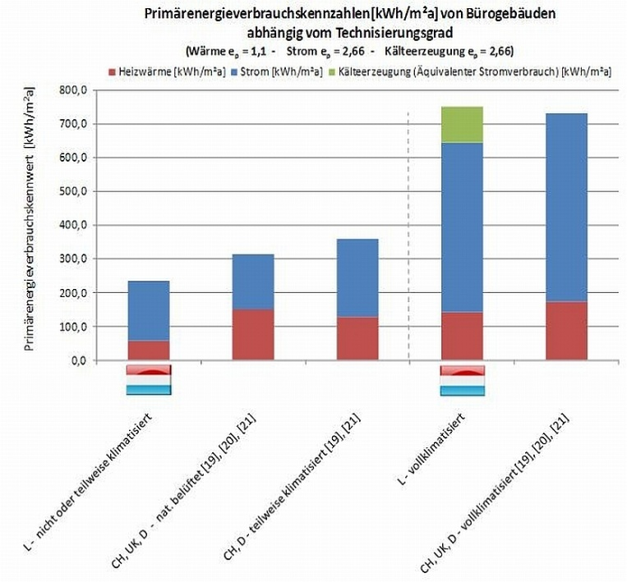Figure 2 Subfigures should be numbered a), b), c) ... etc.

**References**

1. Haenel, J.; Kina, J.; Schaumann, P. (1994) *Zur Erweiterung des Anwendungsbereiches von Stahlträgerverbundkonstruktionen*. Stahlbau **63**, H. 4, pp. 279–283.